Trapping analysis of a magnetized electron by a circularly polarized electromagnetic wave in static electric field
Xinhang Xu¹ (徐新航), Chengming Qu²(渠承明), Xiaoliang Li³(李小良), Xinliang Gao⁵(高新亮), Jian Liu⁴ (刘健) and Jinlin Xie^{1*}(谢锦林)
¹Department of plasma physics and fusion engineering, University of Science and Technology of China, Hefei, Anhui, China

²Institute of Energy, Hefei Comprehensive National Science Center (Anhui Energy Laboratory), Hefei, China

³Chinese Academy of Sciences Institute of Plasma Physics, Hefei, Anhui, China

⁴Weihai Institute for Interdisciplinary Research, Shandong University, Weihai, Shandong, China

⁵CAS Key Laboratory of Geoscience Environment, School of Earth and Space Sciences, University of Science and Technology of China, Hefei, China

*Email: jlxie@ustc.edu.cn
Abstract
A pseudo-potential framework is developed to investigate how a background static electric field influences a velocity-space trapping mechanism, arising from the interaction of a magnetized electron with a circularly polarized electromagnetic wave. The trapping process is associated with anomalous Doppler resonance. When the wave amplitude exceeds a critical threshold relative to the static electric field, the electron’s parallel velocity becomes trapped and oscillates within a pseudo-potential well, while the perpendicular velocity grows continuously as energy from the static electric field is converted into gyro kinetic energy. Numerical simulations reveal the formation of a stable trapping region and determine the threshold condition for trapping. Under typical tokamak plasma parameters, effective trapping requires the wave electric field amplitude to exceed the static electric field by a factor of approximately 10². This threshold is further verified through first-principles calculations. The resulting energy transfer from the static electric field to the gyro kinetic energy during trapping is quantified and shown to agree well with predictions from quantum theory.
I. Introduction
Wave–particle interactions play a central role in plasma physics and are widely exploited for both particle acceleration and confinement. Through appropriate resonance conditions, electromagnetic waves can exchange energy and momentum efficiently with charged particles, leading to a broad range of phenomena in laboratory plasmas, fusion devices, and space environments.
In the context of particle acceleration, one of the most well-known mechanisms is auto resonance, in which a charged particle maintains phase synchronism with an electromagnetic wave through nonlinear effects. A representative example is the gyro-resonant accelerator[1-3], where electrons interact resonantly with a fixed-frequency electromagnetic wave in a slowly varying magnetic field, allowing the relativistic mass increase to compensate for changes in the cyclotron frequency. Velocity-space acceleration may also occur through Landau resonance, in which particles become trapped in the potential well of a longitudinal wave, subsequent variation of the wave phase velocity can then lead to sustained particle acceleration[4].
Particle trapping, on the other hand, is commonly associated with spatial confinement mechanisms, such as optical tweezers or ponderomotive potential wells formed by the interference of electromagnetic waves[5]. In plasma environments, trapping in velocity space has been observed in a variety of wave–particle interactions, including nonlinear interactions between electrons and chorus waves[6], electromagnetic ion cyclotron (EMIC) waves[7], and whistler-mode waves[8]. These processes are of particular importance in both space plasmas and magnetic confinement devices, where they influence particle transport, energy redistribution, and radiation emission.
Despite extensive studies of charged particle interactions with electromagnetic and electrostatic waves in magnetized plasmas[9-17], most theoretical treatments consider electromagnetic waves while ignoring the effects of static electric fields. The combined effect of a static electric field and an electromagnetic wave under a background magnetic field have received comparatively little attention, even though such configurations naturally arise in systems such as tokamak plasmas, where strong toroidal electric fields coexist with wave activity, and in space plasmas, where large-scale electric fields accompany wave–particle interactions. In these environments, static electric fields are known to play a critical role in runaway electron generation[18] and pitch-angle scattering[6] [19], suggesting that their interaction with resonant wave dynamics warrants further investigation.
In this work, we extend the relativistic pseudo-potential framework originally developed by Bellan [9] to study pitch-angle scattering by circularly polarized electromagnetic waves, explicitly incorporating a static electric field parallel to the background magnetic field. The analysis shows that the presence of the static electric field introduces a velocity-space trapping mechanism associated with anomalous Doppler resonance. Numerical simulations demonstrate that when the wave amplitude exceeds a critical threshold, the electron’s parallel velocity becomes trapped and oscillates around the resonant velocity, while the perpendicular velocity grows continuously. The trapping boundary in parameter space is identified and the threshold condition for trapping is determined. For typical tokamak plasma conditions, we found that effective trapping requires the wave's electric field intensity to exceed the background static electric field by a factor of approximately 10². This threshold is further verified through first-principles calculations by directly solving the equation of motion using the Volume-Preserving Algorithm[20, 21]. Furthermore, the energy transfer from the static electric field to the electron gyro kinetic energy is quantified, and the numerical results are shown to agree well with predictions from quantum theory. These results reveal a self-sustained resonant interaction in which energy supplied by the static electric field is continuously converted into gyro kinetic energy.
The remainder of this paper is organized as follows. In Section II, we develop the theoretical framework describing the interaction between a magnetized electron, a circularly polarized electromagnetic wave, and a static electric field. Section III presents numerical simulations of the trapping dynamics and analyzes the conditions required for trapping. In Section IV, the classical results are compared with quantum theoretical predictions. Section V discusses the physical interpretation and potential applications of the trapping mechanism, and Section VI summarizes the main conclusions.

II. electron-electromagnetic wave interaction analysis
2.1 Field equations
To analyze interaction between electron and E.M wave, we consider an E.M wave propagating along uniform magnetic field whose phase velocity $v_{T} = ω/k$, where ω is the angular frequency and k is the wavenumber. The uniform background magnetic field is B₀ = B₀ẑ. The wave's magnetic field perturbation B̃ is characterized by the dimensionless parameter $κ$ ≡ |B̃|/B₀, such that the total magnetic field becomes B = B₀ẑ + B̃. The system includes a static electric field E₀ = E₀ẑ, with the total electric field given by E = E₀ẑ + Ẽ, where Ẽ represents the electric field components of E.M wave:
$$\begin{aligned}\tilde{E}= E_{w} \left[\hat{x}cos\left(kz - ωt\right)+g ŷ sin\left(kz - ωt\right)\right]\#\left( SEQ equation 1\right)\end{aligned}$$
Here, $E_{w}$ is the electric field amplitude of E.M wave, and the polarization satisfies the left-hand circular polarization (LCP) condition when $g$ = 1, and right-hand circular polarization (RCP) condition when $g$ = -1.
Faraday’s law requires the associated magnetic field to be
$$\begin{aligned}\tilde{B}=\frac{k}{ω}\hat{z}×\tilde{E}=κB_{0}\left[-g \hat{x}\sin\left(kz-ωt\right)+\hat{y}\cos\left(kz-ωt\right)\right]\#\left( SEQ equation 2\right)\end{aligned}$$
Here $κB_{0}=B_{w}=\frac{k}{ω}E_{w}$.
2.2 Transformation to the wave frame
In wave frame, which denotes as prime and moves at constant velocity $v_{T} =ω/k$ with respect to the lab frame, the fields are
$$\begin{aligned}E_{∥}^{'}=E_{∥}\#\left( SEQ equation 3\right)\end{aligned}$$
$$\begin{aligned}B_{∥}^{'}=B_{∥}\#\left( SEQ equation 4\right)\end{aligned}$$
$$\begin{aligned}E_{⊥}^{'}=γ_{T}{\left(E+v_{T}×B\right)}_{⊥}\#\left( SEQ equation 5\right)\end{aligned} \\ \begin{aligned}B_{⊥}^{'}=γ_{T}{\left(B-\frac{1}{c^{2}}v_{T}×E\right)}_{⊥}\#\left( SEQ equation 6\right)\end{aligned}$$
Where $γ_{T}=1/\sqrt{1-{\left(\frac{v_{T}}{c}\right)}^{2}}$. Substituting the wave fields Eq. $\left(1\right)$, Eq. $\left(2\right)$ into Eq.$\left(5\right)$, Eq. $\left(6\right)$ gives $E_{⊥}^{'}=0$ and $B_{⊥}^{'}=\frac{B_{⊥}}{γ_{T}}$.
Since $\{k,\frac{iω}{c}\}$ and {x, ict} are relativistic four-vectors, we have $$\begin{aligned}kz-ωt=kγ_{T}\left(z^{'}+v_{T}t^{'}\right)-ωγ_{T}\left(t^{'}+\frac{v_{T}z^{'}}{c^{2}}\right)=k^{'}z^{'}\#\left( SEQ equation 7\right)\end{aligned}$$
Here $k^{'}=k/γ_{T}$ and $z'$ are the wavenumber and position in the wave frame. The magnetic field of E.M wave is
$$\begin{aligned}B_{⊥}^{'}=B_{⊥}^{'}\left( -g \hat{x}\sin\left(k^{'}z^{'}\right)+\hat{y}\cos\left(k^{'}z^{'}\right)\right)\#\left( SEQ equation 8\right)\end{aligned}$$
The motion equation of the charge particle in the prime frame is
$$\begin{aligned}\frac{d}{dt^{'}}\left(γ^{'}β^{'}\right)=\frac{q}{m_{0}}\left(\frac{E_{0}}{c}\hat{z}+β^{'}×B^{'}\right)\#\left( SEQ equation 9\right)\end{aligned}$$
Where $γ^{'}=1/\sqrt{1-{β' }^{2}}$ , m₀ is the rest mass of electron and q is the electron charge with q = -e. Note that $γ$,$γ_{T}$, and $γ'$ differ and should not be confused with each other. The derivation of energy $γ'$ to t’ and the motion equation in each direction should be
$$\begin{aligned}\frac{dγ^{'}}{dt^{'}}=\frac{qE_{0}\hat{z}⋅β_{z}^{'}}{m_{0}c}\#\left( SEQ equation 10\right)\end{aligned}$$
$$\begin{aligned}\frac{d}{dt^{'}}\left(γ^{'}β_{z}^{'}\right)=Ω\left(\frac{E_{0}}{cB_{0}}\hat{z}+β_{⊥}^{'}×\frac{B_{⊥}^{'}}{B_{0}}\right)\#\left( SEQ equation 11\right)\end{aligned}$$
$$\begin{aligned}\frac{d}{dt^{'}}\left(γ^{'}β_{⊥}^{'}\right)=Ω\left(β_{⊥}^{'}×\hat{z}+β_{z}^{'}\hat{z}×\frac{B_{⊥}^{'}}{B_{0}}\right)\#\left( SEQ equation 12\right)\end{aligned}$$
Here $Ω$ is the nonrelativistic electron cyclotron frequency in the lab frame with $Ω<0$. Introduce
$$\begin{aligned}ξ_{z}=1+αγ^{'}β_{z}^{'}\#\left( SEQ equation 13\right)\end{aligned}$$
Here $α= \frac{gω}{Ωγ_{T}}n.$And
$$\begin{aligned}ξ_{⊥}=1+αγ^{'}β_{⊥}^{'}\#\left( SEQ equation 14\right)\end{aligned}$$
where $n=ck/ω$ , according to Eq. $\left(11\right)$ , Eq. $\left(12\right)$, we have
$$\begin{aligned}\frac{dξ_{z}}{dt^{'}}=αΩ\left(\frac{E_{0}}{cB_{0}}\hat{z}+\frac{ξ_{⊥}-1}{αγ'}×\frac{B_{⊥}^{'}}{B_{0}}\right)⋅\hat{z}\#\left( SEQ equation 15\right)\end{aligned}$$
$$\begin{aligned}\frac{dξ_{⊥}}{dt^{'}}=αΩ\left(\frac{ξ_{⊥}-1}{αγ'}×\hat{z}+\frac{ξ_{z}-1}{αγ'}\hat{z}×\frac{B_{⊥}^{'}}{B_{0}}\right)\#\left( SEQ equation 16\right)\end{aligned}$$
2.3 Construction of pseudo-potential equation
Taking the derivative of Eq. $\left(15\right)$ with respect to t’ gives
$$\begin{aligned}\frac{d^{2}ξ_{z}}{d{t^{'}}^{2}}=αΩ\left(\frac{d}{dt^{'}}\left(\frac{ξ_{⊥}-1}{αγ^{'}}\right)×\frac{B_{⊥}^{'}}{B_{0}}\right)⋅\hat{z}+αΩ\left(\frac{ξ_{⊥}-1}{αγ^{'}}×\frac{d}{dt^{'}}\left( \frac{B_{⊥}^{'}}{B_{0}}\right)\right)⋅\hat{z}\#\left( SEQ equation 17\right)\end{aligned}$$
And
$$\begin{aligned}\frac{d}{dt^{'}}\left(\frac{ξ_{⊥}-1}{αγ^{'}}\right)=\frac{1}{αγ^{'}}⋅\frac{dξ_{⊥}}{dt^{'}}-\frac{ξ_{⊥}-1}{α{γ^{'}}^{2}}\frac{dγ^{'}}{dt} \#\left( SEQ equation 18\right)\end{aligned}$$
According to Eq. $\left(10\right)$ and $ξ_{z}$, we have
$$\begin{aligned}\frac{dγ^{'}}{dt'}=Ω\frac{E_{0}}{B_{0}c}\frac{ξ_{z}-1}{αγ^{'}}\#\left( SEQ equation 19\right)\end{aligned}$$
While in Eq. $\left(29\right)$, assuming $β_{⊥}^{'}≪β_{z}^{'}$ and $B_{⊥}^{'}<B_{0}$ ,we obtain
$$\begin{aligned}\left|\frac{dξ_{⊥}}{dt^{'}}\right|<\left|Ω\frac{ξ_{z}-1}{γ^{'}}\right| \#\left( SEQ equation 20\right)\end{aligned}$$
Finally, in the right side of Eq. $\left(18\right)$
$$\begin{aligned}\frac{\left|\frac{ξ_{⊥}-1}{α{γ^{'}}^{2}}⋅\frac{dγ^{'}}{dt'}\right|}{\left|\frac{1}{αγ'}⋅\frac{dξ_{⊥}}{dt'}\right|}<\frac{E_{0}β_{⊥}^{'}}{B_{0}c}\#\left( SEQ equation 21\right)\end{aligned}$$
While for $β_{⊥}^{'}≪1$and $|\frac{E_{0}}{B_{0}c}|≪1$ , we can confidently ignore the second term in the right side of Eq. $\left(18\right)$, then
$$\begin{aligned}\frac{d}{dt^{'}}\left(\frac{ξ_{⊥}-1}{αγ^{'}}\right)=\frac{1}{αγ^{'}}⋅\frac{dξ_{⊥}}{dt^{'}}\#\left( SEQ equation 22\right)\end{aligned}$$
Combing Eq. $\left(17\right)$ with Eq. $\left(22\right)$ , we have
$$\begin{aligned}\frac{d^{2}ξ_{z}}{d{t^{'}}^{2}}=αΩ\left(\frac{1}{αγ^{'}}⋅\frac{dξ_{⊥}}{dt^{'}}×\frac{B_{⊥}^{'}}{B_{0}}\right)⋅\hat{z}+αΩ\left(\frac{ξ_{⊥}-1}{αγ^{'}}×\frac{d}{dt^{'}}\left( \frac{B_{⊥}^{'}}{B_{0}}\right)\right)⋅\hat{z}\#\left( SEQ equation 23\right)\end{aligned}$$
Substituting Eq. $\left(29\right)$ into Eq. $\left(23\right)$ gives
$$\begin{aligned}\frac{d^{2}ξ_{z}}{d{t^{'}}^{2}}=αΩ\left[\frac{Ω}{γ^{'}}\left(β_{⊥}^{'}×\hat{z}+β_{z}^{'}\hat{z}×\frac{B_{⊥}^{'}}{B_{0}}\right)×\frac{B_{⊥}^{'}}{B_{0}}+β_{⊥}^{'}×\frac{d}{dt^{'}}\left( \frac{B_{⊥}^{'}}{B_{0}}\right)\right]⋅\hat{z}\#\left( SEQ equation 24\right)\end{aligned}$$
The time derivation of wave magnetic field in wave frame is
$$\begin{aligned}\frac{dB_{⊥}^{'}}{dt^{'}}=-k^{'}\frac{dz^{'}}{dt^{'}}B_{⊥}^{'}(g \hat{x}\cos\left(k^{'}z^{'}\right)+\hat{y}\sin\left(k^{'}z^{'}\right)=gωn^{'}β_{z}^{'}\hat{z}×B_{⊥}^{'}\#\left( SEQ equation 25\right)\end{aligned}$$
where $n^{'}=\frac{ck^{'}}{ω}=n/γ_{T}$. By substituting Eq. $\left(25\right)$ into Eq. $\left(24\right)$$\left(23\right)$ and simplify Eq. $\left(24\right)$ gives
$$\begin{aligned}\frac{d^{2}ξ_{z}}{d{t^{'}}^{2}}=\frac{αΩ^{2}}{γ^{'}}\left(\frac{β_{⊥}^{'}⋅B_{⊥}^{'}}{B_{0}}(1+\frac{gωn}{Ωγ_{T}}γ^{'}β_{z}^{'})-β_{z}^{'}\frac{B_{⊥}^{'}}{B_{0}}⋅\frac{B_{⊥}^{'}}{B_{0}}\right) \#\left( SEQ equation 26\right)\end{aligned}$$
Since $ξ_{z}=1+\frac{gωn}{Ωγ_{T}}γ^{'}β_{z}^{'}$, finally
$$\begin{aligned}\frac{d^{2}ξ_{z}}{d{t^{'}}^{2}}=\frac{αΩ^{2}}{γ^{'}}\left(\frac{β_{⊥}^{'}⋅B_{⊥}^{'}}{B_{0}}ξ_{z}-β_{z}^{'}\frac{B_{⊥}^{'}}{B_{0}}⋅\frac{B_{⊥}^{'}}{B_{0}}\right) \#\left( SEQ equation 27\right)\end{aligned}$$

2.3.1 connect $\frac{β_{⊥}^{'}⋅B_{⊥}^{'}}{B_{0}}$ with $ξ_{z}$
To obtain the relationship between $\frac{β_{⊥}^{'}⋅B_{⊥}^{'}}{B_{0}}$ and $ξ_{z}$, taking the time derivation of $\frac{β_{⊥}^{'}⋅B_{⊥}^{'}}{B_{0}}$ gives
$$\begin{aligned}\frac{d}{{dt}^{'}}\left(\frac{β_{⊥}^{'}⋅B_{⊥}^{'}}{B_{0}}\right)=\frac{dβ_{⊥}^{'}}{dt^{'}}⋅\frac{B_{⊥}^{'}}{B_{0}}+β_{⊥}^{'}⋅\frac{d}{dt^{'}}\left(\frac{B_{⊥}^{'}}{B_{0}}\right)\#\left( SEQ equation 28\right)\end{aligned}$$
According to Eq. $\left(10\right)$ and Eq. $\left(12\right)$, we have
$$\begin{aligned}\frac{dβ_{⊥}^{'}}{dt^{'}}=Ω^{'}\left(β_{⊥}^{'}×\hat{z}+β_{z}^{'}\left(\hat{z}×\frac{B_{⊥}^{'}}{B_{0}}\right)\right)-\frac{Ω^{'}E_{0}\hat{z}⋅β_{z}^{'}}{cB_{0}}β_{⊥}^{'}\#\left( SEQ equation 29\right)\end{aligned}$$
Here $Ω^{'}=Ω/γ'$. Substituting Eq. $\left(29\right)$ into Eq. $\left(28\right)$ gives
$$\begin{aligned}\frac{dβ_{⊥}^{'}}{dt^{'}}⋅\frac{B_{⊥}^{'}}{B_{0}}=-\hat{z}⋅\left(β_{⊥}^{'}×\frac{B_{⊥}^{'}}{B_{0}}\right)Ω^{'}-Ω^{'}\frac{E_{0}β_{z}^{'}}{cB_{0}}\left(β_{⊥}^{'}⋅\frac{B_{⊥}^{'}}{B_{0}}\right)\#\left( SEQ equation 30\right)\end{aligned}$$
and$$\begin{aligned}β_{⊥}^{'}⋅\frac{d}{dt^{'}}\left(\frac{B_{⊥}^{'}}{B_{0}}\right)=β_{⊥}^{'}⋅gωn^{'}β_{z}^{'}\left(\hat{z}×\frac{B_{⊥}^{'}}{B_{0}}\right)=-gωn^{'}β_{z}^{'}\left(β_{⊥}^{'}×\frac{B_{⊥}^{'}}{B_{0}}\right)⋅\hat{z}\#\left( SEQ equation 31\right)\end{aligned}$$
Finally, we have
$$\begin{aligned}\frac{d}{{dt}^{'}}\left(\frac{β_{⊥}^{'}⋅B_{⊥}^{'}}{B_{0}}\right)={-ξ_{z}Ω}^{'}\hat{z}⋅\left(β_{⊥}^{'}×\frac{B_{⊥}^{'}}{B_{0}}\right)-Ω^{'}\frac{E_{0}β_{z}^{'}}{cB_{0}}\left(\frac{β_{⊥}^{'}⋅B_{⊥}^{'}}{B_{0}}\right)\#\left( SEQ equation 32\right)\end{aligned}$$
The equation is first-order linear differential equation with the form:
$$\begin{aligned}T^{'}\left(τ\right)+PT\left(τ\right)=Q\left(τ\right)\#\left( SEQ equation 33\right)\end{aligned}$$
Where $P= \frac{E_{0}β_{z}^{'}}{cB_{0}} , Q=-ξ\hat{z}⋅\left(β_{⊥}^{'}×\frac{B_{⊥}^{'}}{B_{0}}\right) and τ=t^{'}Ω'.$ The exact solution of z is
$$\begin{aligned}T=e^{-∫Pdτ}*\left[\int{e^{∫Pdτ^{'}}Qdτ+C_{0}}\right]\#\left( SEQ equation 34\right)\end{aligned}$$
Since |P|<< 1 in most case of Tokamak environment, we have
$$\begin{aligned}T=\int{Qdτ}\#\left( SEQ equation 35\right)\end{aligned}$$
Here we choose the initial condition $|{β_{⊥}^{'}}_{0}|≪1$, which implies C₀ = 0. As a result, the expression Eq. $\left(32\right)$ can simplify to:
$$\begin{aligned}\frac{d}{{dt}^{'}}\left(\frac{β_{⊥}^{'}⋅B_{⊥}^{'}}{B_{0}}\right)={-ξ_{z}Ω}^{'}\hat{z}⋅\left(β_{⊥}^{'}×\frac{B_{⊥}^{'}}{B_{0}}\right)\#\left( SEQ equation 36\right)\end{aligned}$$
The substitution of Eq. $\left(15\right)$ into Eq. $\left(36\right)$ gives
$$\begin{aligned}\frac{d}{{dt}^{'}}\left(\frac{β_{⊥}^{'}⋅B_{⊥}^{'}}{B_{0}}\right)={-ξ_{z}Ω}^{'}\left(\frac{1}{αΩ}\frac{dξ_{z}}{dt^{'}}-\frac{E_{0}}{cB_{0}}\right)\#\left( SEQ equation 37\right)\end{aligned}$$
Integrating Eq. $\left(37\right)$ with $t^{'}$ gives:
$$\begin{aligned}\frac{β_{⊥}^{'}⋅B_{⊥}^{'}}{B_{0}}=-\frac{ξ_{z}^{2}-{ξ_{z}}_{0}^{2}}{2αγ^{'}}+\frac{E_{0}}{cB_{0}}∫ξ_{z}Ω^{'}dt^{'}+\frac{β_{⊥0}^{'}⋅B_{⊥0}^{'}}{B_{0}}\#\left( SEQ equation 38\right)\end{aligned}$$
Here $ξ_{z0}$,$β_{⊥0}^{'}$ and $B_{⊥0}^{'}$ represent the initial condition of $ξ_{z}$, $β_{⊥}^{'}$ and $B_{⊥}^{'}$.
Noting that t = 0 corresponds to z’=0, since z = 0 at t= 0, and recalling the four vectors {$γβ,γ$}, we have the relation:
$$\begin{aligned}γ_{0}^{'}β_{⊥0}^{'}=γ_{0}β_{⊥0}\#\left( SEQ equation 39\right)\end{aligned}$$
Since $B_{⊥0}^{'}$ is in the y direction when z’ = 0 as shown in Eq. $\left(8\right)$, it follows that
$$\begin{aligned}\frac{β_{⊥0}^{'}⋅B_{⊥0}^{'}}{B_{0}}=\frac{β_{y0}^{'}B_{⊥}^{'}}{B_{0}}=\frac{γ_{0}}{γ_{0}^{'}}κ^{'}β_{⊥0}\sin{ϕ_{0}}\#\left( SEQ equation 40\right)\end{aligned}$$
Where $ϕ_{0}$ is defined by $β_{x0}=β_{⊥0}cosϕ_{0}$ and $β_{y0}=β_{⊥0}\sin{ϕ_{0}}$ , $κ^{'}=\frac{κ}{γ_{T}}=\frac{B_{⊥}^{'}}{B_{0}}$. With these definitions, Eq. $\left(38\right)$ becomes
$$\begin{aligned}\frac{β_{⊥}^{'}⋅B_{⊥}^{'}}{B_{0}}=-\frac{ξ_{z}^{2}-{ξ_{z}}_{0}^{2}}{2αγ^{'}}+\frac{E_{0}}{cB_{0}}∫ξ_{z}Ω^{'}dt^{'}+\frac{γ_{0}}{γ_{0}^{'}}κ^{'}β_{⊥0}\sin{ϕ_{0}}\#\left( SEQ equation 41\right)\end{aligned}$$
The substitution of Eq. $\left(41\right)$ into Eq. $\left(27\right)$ gives:
$$\begin{aligned}\frac{d^{2}ξ_{z}}{d{t^{'}}^{2}}=\frac{αΩ^{2}}{γ^{'}}\left(\left(-\frac{ξ_{z}^{2}-ξ_{z0}^{2}}{2αγ^{'}}+\frac{E_{0}}{cB_{0}}∫ξ_{z}Ω^{'}dt^{'}+\frac{γ_{0}}{γ_{0}^{'}}κ^{'}β_{⊥0}\sin{ϕ_{0}}\right)ξ_{z}-β_{z}^{'}κ^{'2}\right)\#\left( SEQ equation 42\right)\end{aligned}$$
Simplifying Eq. $\left(42\right)$ and substituting $ξ_{z}$ for $β_{z}^{'}$ gives:
$$\begin{aligned}\frac{d^{2}ξ_{z}}{d{t^{'}}^{2}}={Ω^{'}}^{2}\left(ξ_{z}\left(-\frac{ξ_{z}^{2}-ξ_{z0}^{2}}{2}+\frac{{ ςE}_{0}}{cB_{0}}∫{Ω^{'}ξ}_{z}dt^{'}+αγ_{0}κ^{'}β_{⊥0}\sin{ϕ_{0}}\right)-\left(ξ_{z}-1\right)κ^{'2}\right)\#\left( SEQ equation 43\right)\end{aligned}$$
Here
$$\begin{aligned}ς= g\frac{ωn}{Ωγ_{T}}γ^{'}\#\left( SEQ equation 44\right)\end{aligned}$$
Normalization of time $t'$ with $τ=t'Ω'$ we have
$$\begin{aligned}\frac{d^{2}ξ_{z}}{dτ^{2}}=\left(ξ_{z}\left(-\frac{ξ_{z}^{2}-ξ_{z0}^{2}}{2}+\frac{{ ςE}_{0}}{cB_{0}}∫ξ_{z}dτ+αγ_{0}κ^{'}β_{⊥0}\sin{ϕ_{0}}\right)-\left(ξ_{z}-1\right)κ^{'2}\right)\#\left( SEQ equation 45\right)\end{aligned}$$
The Eq. $\left(45\right)$could also be written as
$$\begin{aligned}\frac{d^{2}ξ_{z}}{dτ^{2}}=-\frac{∂ψ}{∂ξ_{z}}\#\left( SEQ equation 46\right)\end{aligned}$$
Where
$$\begin{aligned}-\frac{∂ψ}{∂ξ_{z}}=\left(ξ_{z}\left(-\frac{ξ_{z}^{2}-ξ_{z0}^{2}}{2}+\frac{{ςE}_{0}}{cB_{0}}∫ξ_{z}dτ+αγ_{0}κ^{'}β_{⊥0}\sin{ϕ_{0}}\right)-\left(ξ_{z}-1\right)κ^{'2}\right)\#\left( SEQ equation 47\right)\end{aligned}$$
Multiplying Eq. $\left(46\right)$ by $dξ_{z}/dτ$and integrating gives a pseudo-energy equation
$$\begin{aligned}\frac{1}{2}{\left(\frac{dξ_{z}}{dτ}\right)}^{2}+ψ\left(ξ_{z}\right)=W_{0}\#\left( SEQ equation 48\right)\end{aligned}$$
Where pseudo-potential equation is
$$\begin{aligned}ψ=\frac{1}{8}ξ_{z}^{4}+\left(κ^{'2}-\frac{ξ_{z0}^{2}}{2}-gsκ^{'}sinϕ_{0}\right)\frac{ξ_{z}^{2}}{2}-κ^{'2}ξ_{z}-\int{ξ_{z}\frac{{ςE}_{0}}{cB_{0}}∫ξ_{z}dτdξ}\#\left( SEQ equation 49\right)\end{aligned}$$
And
$$\begin{aligned}W_{0}=\frac{1}{2}{\left(\frac{dξ_{z}}{dτ}\right)}^{2}{\left.​\right|}_{τ=0}+ψ\left(ξ_{z0}\right)\#\left( SEQ equation 50\right)\end{aligned}$$
Here $s=\frac{ωnβ_{⊥0}γ_{0}}{Ωγ_{T}}$.The pseudo potential $ψ$ can only be solved numerically, as it does not have a regular form involving only the parameter $ξ$, here $ψ$ also depends on t’, which is related to $β_{z}^{'}$ and $β_{⊥}^{'}$.
When $E_{0}=0$, the pseudo-potential equation reduces to
$$\begin{aligned}ψ=\frac{1}{8}ξ_{z}^{4}+\left(κ^{'2}-\frac{ξ_{z0}^{2}}{2}-gsκ^{'}sinϕ_{0}\right)\frac{ξ_{z}^{2}}{2}-κ^{'2}ξ_{z}\#\left( SEQ equation 51\right)\end{aligned}$$
which has the same expression as Eq. (41) in Ref. [9], as derived by P. M. Bellan.
2.4 Initial condition
From Eq. $\left(15\right)$, we see that
$$\begin{aligned}\frac{dξ_{z}}{dτ}=g\left(\frac{ωn}{Ωγ_{T}}κ^{'}γ\left(β_{x}\cos\left(kz-ωt\right)+gβ_{y}\sin\left(kz-ωt \right)\right)\right)+\frac{{ςE}_{0}}{cB_{0}}\#\left( SEQ equation 52\right)\end{aligned}$$
Here, we use the relation $γβ_{⊥}=γ^{'}β_{⊥}^{'}$ and $κ^{'}=B_{⊥}^{'}/B_{0}$. At the initial time $t$= 0 and position z = 0, we have
$$\begin{aligned}\frac{dξ_{z}}{dτ}{\left.​\right|}_{τ=0}=gsκ^{'}cosϕ_{0}+\frac{{ςE}_{0}}{cB_{0}}\#\left( SEQ equation 53\right)\end{aligned}$$
2.6 Solve $β_{⊥}$
According to Eq.$\left(12\right)$, multiplying ${γ'β}_{⊥}^{'}$ on both sides gives
$$\begin{aligned}\frac{1}{2}\frac{d({{γ'β}_{⊥}^{'})}^{2}}{dt^{'}}=Ωγ^{'}β_{⊥}^{'}⋅\left(β_{z}^{'}×\frac{B_{⊥}^{'}}{B_{0}}\right)\#\left( SEQ equation 54\right)\end{aligned}$$
Reorganize the equation, we have
$$\begin{aligned}\frac{1}{2}\frac{d({{γ'β}_{⊥}^{'})}^{2}}{dt^{'}}=-Ωγ^{'}β_{z}^{'}⋅\left(β_{⊥}^{'}×\frac{B_{⊥}^{'}}{B_{0}}\right)\#\left( SEQ equation 55\right)\end{aligned}$$
According to Eq.$\left(11\right)$, multiplying ${γ'β}_{z}^{'}$ on both sides gives
$$\begin{aligned}\frac{1}{2}\frac{d({{γ'β}_{z}^{'})}^{2}}{dt^{'}}=Ωγ^{'}β_{z}^{'}⋅\left(\frac{E_{0}}{cB_{0}}\hat{z}+β_{⊥}^{'}×\frac{B_{⊥}^{'}}{B_{0}}\right)\#\left( SEQ equation 56\right)\end{aligned}$$
Add Eq. $\left(55\right)$ and Eq. $\left(56\right)$, we have
$$\begin{aligned}\frac{1}{2}\frac{d({{γ'β}_{⊥}^{'})}^{2}}{dt^{'}}+\frac{1}{2}\frac{d({{γ'β}_{z}^{'})}^{2}}{dt^{'}}=\frac{Ωγ^{'}E_{0}β_{z}^{'}}{cB_{0}}\#\left( SEQ equation 57\right)\end{aligned}$$
Which means energy change ratio equal to work done by static electric field in moving frame.
Using the normalized time $τ=t^{'}Ω'$, we have
$$\begin{aligned}\frac{1}{2}\frac{d({{γ^{'}β}_{⊥}^{'})}^{2}}{dτ}+\frac{1}{2}\frac{d({{γ^{'}β}_{z}^{'})}^{2}}{dτ}=\frac{{γ^{'}}^{2}E_{0}β_{z}^{'}}{cB_{0}}\#\left( SEQ equation 58\right)\end{aligned}$$
Considering that $γ'$ is mainly determined by $β_{z}^{'}$, integrating both sides with t’ gives
$$\begin{aligned}{β'}_{⊥}^{2}=\frac{2}{{γ^{'}}^{2}{\left.​\right|}_{t}}⋅\int_{0}^{t}{\frac{{γ^{'}}^{2}E_{0}β_{z}^{'}}{cB_{0}}}dτ+\left({β_{z0}^{'}}^{2}+{β_{⊥0}^{'}}^{2}\right)-{β'}_{z}^{2}\#\left( SEQ equation 59\right)\end{aligned}$$

III. Numerical study of the trapping effect
According to Eq. $\left(46\right)$, Eq. $\left(47\right)$ and Eq.$\left(53\right)$, the velocity $β_{z}^{'}$ could be numerically solved by ode45, and $β_{⊥}^{'}$ can be determined from Eq.$\left(59\right)$. Then, using the four-vector {$γβ,γ$}, we have:
$$\begin{aligned}γ=β_{T}γ_{T}γ^{'}β_{z}^{'}+γ_{T}γ^{'}\#\left( SEQ equation 60\right)\end{aligned}$$
$$\begin{aligned}β_{⊥}=\frac{γ^{'}β_{⊥}^{'}}{γ}\#\left( SEQ equation 61\right)\end{aligned}$$
$$\begin{aligned}β_{z}=\frac{γ_{T}γ^{'}}{γ}\left(β_{z}^{'}+β_{T}\right)\#\left( SEQ equation 62\right)\end{aligned}$$
Finally, all the velocities in lab frame can be solved numerically
Quantum analysis reveals that wave polarization in anomalous Doppler resonance with electrons is predominantly determined by the LCP component[22]. Two cases are considered in which an LCP electromagnetic wave interacts with an electron within uniform magnetic and static electric fields.
In case I, considering a scenario where the uniform magnetic field B₀​ = 2 T and the static electric field E₀ = −0.2 V/m, both along the z-axis, which are close to typical Tokamak plasma conditions. A plane LCP E.M wave is assumed to propagate along z direction with refractive index $n=4$ where $ω=1.1 Ω$ and k = 1290 m⁻¹[23]. The electric field of E.M wave is set to $E_{ω}=20 V/m$. The numerical results are shown in Fig. 1, For the static electric field E₀ < 0, the direction of the electric field is opposite to that of the background magnetic field. As a result, the parallel velocity increases over time, as shown in Fig.1(a). Since here $α<0$, which is given in Eq. $\left(13\right)$, the value of $ξ_{z}$ decreases as $β_{z}$ increase. When the parallel velocity satisfies the anomalous doppler resonance condition where $ξ_{z}=0$, the perpendicular velocity $β_{⊥}$ increase abruptly, as shown in Fig.1 (b-d). After the parallel velocity exceeds the resonance condition, the $β_{⊥}$ will no longer increase. The phase evolution of $ξ_{z}$ and $\frac{1}{Ω^{'}}\frac{dξ_{z}}{{dt}^{'}}$ is shown in fig.(e). It can be observed that the fluctuation of $\frac{1}{Ω^{'}}\frac{dξ_{z}}{{dt}^{'}}$ is stronger for $ξ_{z}<0$ than for $ξ_{z}>0$. This is because the change of $\frac{1}{Ω^{'}}\frac{dξ_{z}}{{dt}^{'}}$ is proportional to $β_{⊥}$ as shown in Eq. $\left(52\right)$. An increase in $β_{⊥}$ therefore leads to stronger fluctuations in $\frac{1}{Ω^{'}}\frac{dξ_{z}}{{dt}^{'}}$. Fig 1.(f) illustrates the pseudo-potential $Δψ\left(ξ\right)$ , defined as $Δψ\left(ξ\right)=ψ\left(ξ\right)-ψ\left(ξ_{0}\right)$ .The initial pseudo-kinetic energy is $W_{0}=\frac{1}{2}{\left(\frac{dξ_{z}}{dt^{'}}\right)}^{2}{\left.​\right|}_{t^{'}=0}$, indicated by the red dash line in Fig.1 (f). The pseudo-potential $Δψ\left(ξ\right)$ cannot exceed $W_{0}$ due to the conservation of pseudo energy, as given in Eq. $\left(48\right)$ , where $\frac{1}{2}{\left(\frac{dξ_{z}}{dτ}\right)}^{2}≥ 0$ must always be satisfied.
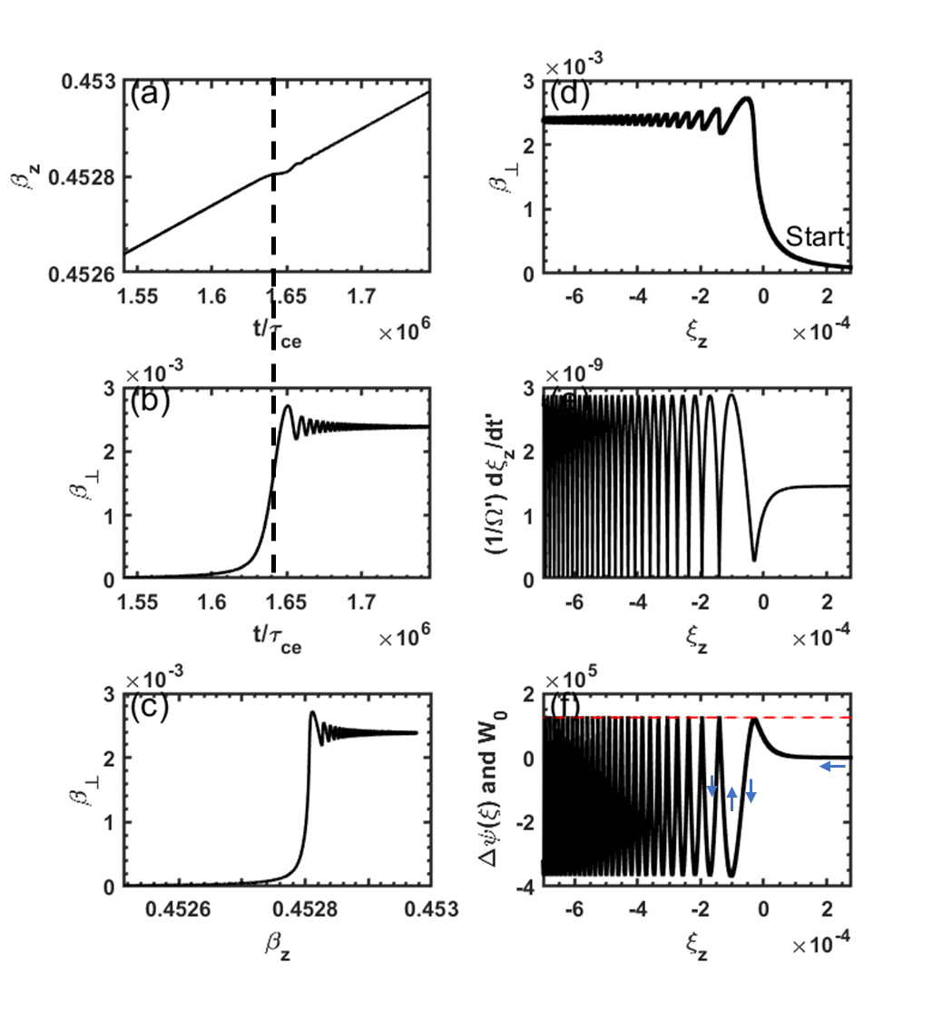
Figure 1. Numerical integration of Eq. $\left(45\right)$ with initial equation Eq.$\left(53\right)$. Input parameters are E₀ =- 0.2 V/m, E_{w} = 20 V/m, B₀ = 2 T, $ω/Ω=-1.1$,g = 1, initial $β_{z}$= 0.45 and $β_{⊥}=0$, $ϕ_{0}=$ 0, n = 4. This give $κ^{'}≈1.29×{10}^{-7},γ_{T}=1.0308,α=-4.373, γ_{0}=1.1198 and γ^{'}=1.0264, \frac{{ςE}_{0}}{cB_{0}}=1.458×{10}^{-9}.$ (a) The time evolution of $β_{z}$, here $τ_{ce}$ refers to the cyclotron period of electron. (b) The time evolution of $β_{⊥}$.(c)The velocity phase in ( $β_{z}$ , $β_{⊥})$. (d)The evolution of $β_{⊥}$ with $ξ_{z}$. (e) The evolution of $dξ_{z}/dτ$ with ξ_{z}. (f)The pseudo-potential $Δψ\left(ξ\right)$ (black line) and the initial pseudo-kinetic energy W₀ (red dash line)
In case II, the electric field of the LCP E.M wave is increased to $E_{ω}=22 V/m$. As the electron’s parallel velocity approaches the resonant velocity, it no longer increases continuously but begins to oscillate around the resonant velocity, as shown in Fig. 2(a). While on the other hand, the perpendicular velocity increases continuously when $β_{z}$ trapping in resonant region, as shown in Fig.2 (b-d). The phase trajectory of ($ξ_{z},\frac{1}{Ω^{'}}\frac{dξ_{z}}{dt^{'}})$ is shown in Fig.2 (e). The closed-loop structure indicates periodic motion around the resonant point, and the direction of motion is labeled with arrow. The electron can only propagate within the region where the pseudo-potential $Δψ\left(ξ\right)$ is lower than the initial pseudo-kinetic energy W₀. When the pseudo-potential tends to surpass the W₀, the electron velocity rebounds upon reaching the boundary of the pseudo-potential well. Consequently, the electron becomes confined within the well, the width of the pseudo-potential well also increases, since it is influenced by the parameter $β_{⊥}$. This bounce effect, shown in Fig.2 (f), illustrates the trapping phenomenon.
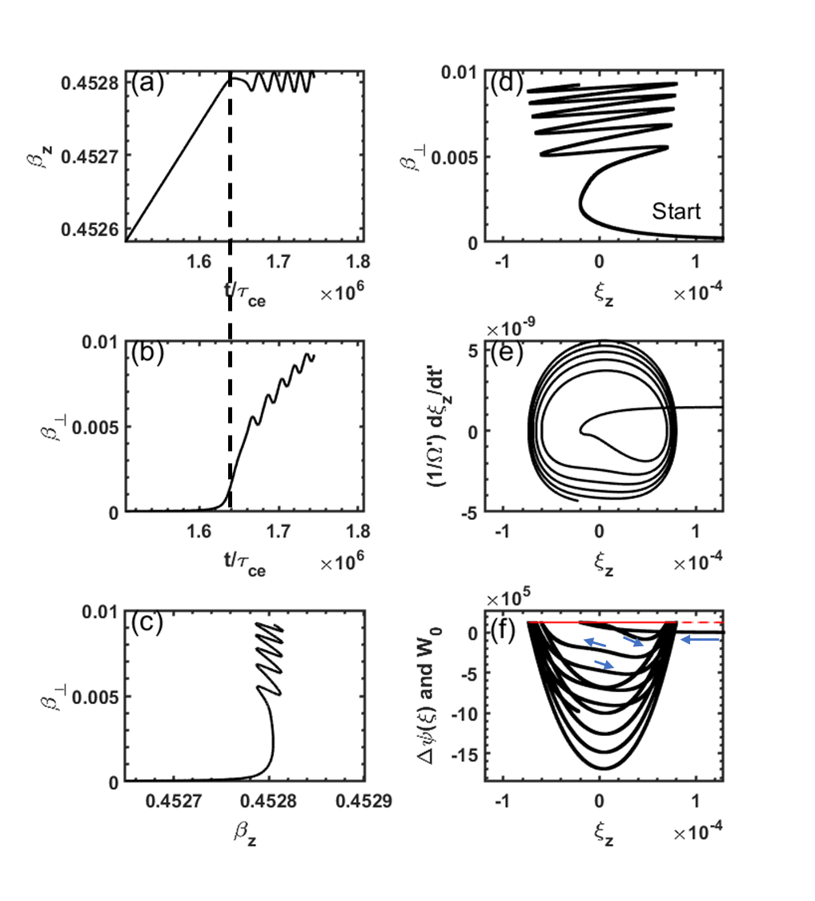
Figure 2. Same as Fig. (1) except with E_{W} = 22 V/m. This gives $κ^{'}= 1.38×{10}^{-7}$but same $\frac{{ςE}_{0}}{cB_{0}}=1.458×{10}^{-9}$.Panels (e) and (f) are zoom in near the resonant condition $ξ_{z}=0$.

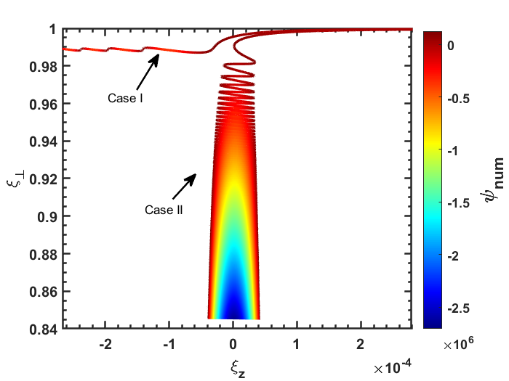
Figure 3. Pseudo-potential Δψ mapped along the electron trajectory in the ($ξ_{z},ξ_{⊥}$) plane.

Since the pseudo-potential Δψ(ξ) is a function of both $β_{z}$and $β_{⊥}$​, we traced Δψ along the particle trajectory in the ($ξ_{z}, ξ_{⊥}$) phase space. This approach highlights the underlying structure of the pseudo-potential and enables clearer physical interpretation. As shown in Fig. 3, which compares the two scenarios described in Case I and Case II. It can be seen that when the electron becomes trapped under the resonant condition, it slips into a “deep potential valley” that extends further along the $ξ_{⊥}$ direction. In contrast, if the electron passes through the resonant region without being trapped, it continues on a “highway”-like trajectory without further obstruction.
To determine the critical boundary of the trapping region, we refer to Eq. $\left(45\right)$and Eq.$\left(52\right)$. Assuming the initial perpendicular velocity is approximately zero ( $β_{⊥0}=0$), then s =0. Under this condition, the dynamics are governed solely by two coefficients: $κ'$ and $\frac{ςE_{0}}{cB_{0}}$，$ξ_{z0}$ is inconsequential provided it lies outside of resonant region, as demonstrated in Fig.2 (e) and (f), where the $ξ_{z}$ is mainly shifted by static electric field before the resonance at $ξ_{z}=0$. As shown in Fig. 4, the trapping region is indicated in yellow, while the blue region corresponds to the passing regime. Case I and Case II are marked with star symbols in the figure, located in the passing and trapping regions, respectively. For special case as given in Fig.1, where $\frac{{ςE}_{0}}{cB_{0}}=1.458×{10}^{-9},$ the critical threshold is $κ_{c}^{'}=1.367×{10}^{-7}$, and $\frac{E_{⊥c}}{|E_{0}|}=\frac{κ_{c}^{'}γ_{T}cB_{0}}{n\left|E_{0}\right|}≈106$. Consequently, effective electron trapping in the electromagnetic wave requires the LCP electric field intensity to exceed the background static electric field by a factor of more than 106 in typical tokamak plasma with frequencies near the upper-hybrid mode. This result is also cross-checked by a first-principles calculation presented in Appendix B.
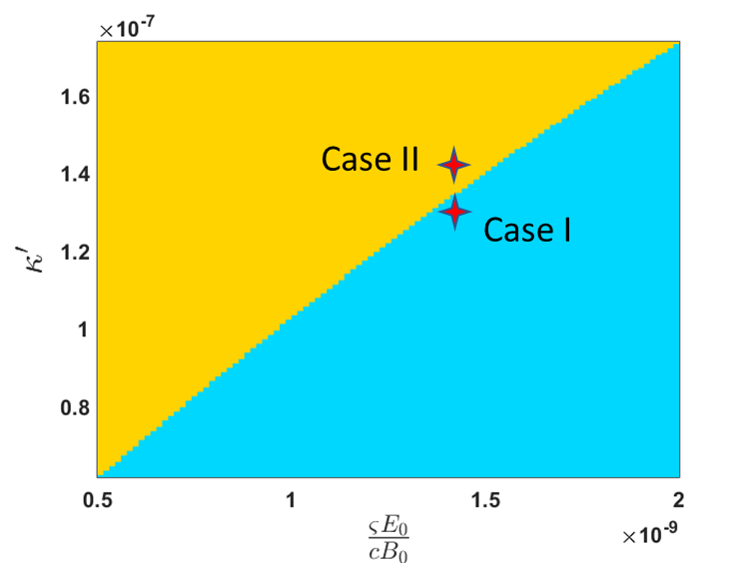
Figure 4. Parameter space of ($\frac{ςE_{0}}{cB_{0}},κ'$) showing electron trapping (yellow) and passing (blue) regimes.

IV. Benchmark with quantum theory
One characteristic worth pointing out is that when the electron is trapped in the electromagnetic wave, the energy transfer from the static electric field to the gyro kinetic energy is governed by quantum theory (QE theory) [22, 24].
$$\begin{aligned}η_{⊥}=\frac{n\left|Ω\right|/γ_{c}}{k⋅v}\#\left( SEQ equation 63\right)\end{aligned}$$
Here $γ_{c}$ refers to the Lorentz factor during the resonance. For anomalous Doppler resonance, n = 1 and $k⋅v=ω+|Ω|/γ_{c}$ , $η_{⊥}$ can be written as
$$\begin{aligned}η_{⊥}=\frac{1}{1+\left|ω/Ω\right|γ_{c}}\#\left( SEQ equation 64\right)\end{aligned}$$
For Case II, $\frac{ω}{Ω}=-1.1$and $γ_{c}=1.1215$ we have $η_{⊥}=$0.448. To numerically calculate the energy transfer ratio, we evaluate the work done by the static electric field during resonance:

$$\begin{aligned}W_{E}=\int_{0}^{t}{E_{0}qv_{z}dt}-\int_{0}^{t_{c}}{E_{0}qv_{z}dt}\#\left( SEQ equation 65\right)\end{aligned}$$
Here $τ_{c}$ refers to the beginning of trapping condition. Before the trapping condition where $t<τ_{c}$, The work done by the static electric field is expressed as:
$$\begin{aligned}W_{E}=\int_{0}^{t}{E_{0}qv_{z}dt}\#\left( SEQ equation 66\right)\end{aligned}$$
The increase in perpendicular energy is given by
$$\begin{aligned}W_{⊥}=\frac{1}{2}m_{0}v_{⊥}^{2}\#\left( SEQ equation 67\right)\end{aligned}$$
Since the $W_{⊥}≈0$ before the resonance happens, we can use the $W_{⊥}$ directly as the increasement from the resonant condition. Finally, the energy transfer ratio is calculated as $η_{⊥}=W_{⊥}/W_{E}$.
The energy transfer ratio from the static electric field to parallel kinetic energy is:
$$\begin{aligned}η_{∥}=\frac{W_{∥}}{W_{E}}\#\left( SEQ equation 68\right)\end{aligned}$$
Here $W_{∥}=\frac{1}{2}m_{0}v_{∥}^{2}-\frac{1}{2}m_{0}v_{0}^{2}$ and $W_{E}=\int_{0}^{t}{E_{0}qv_{z}dt}$ for $t<τ_{c}$ ,where $v_{0}$ refers to the initial velocity, while $W_{∥}=\frac{1}{2}m_{0}v_{∥}^{2}-\frac{1}{2}m_{0}v_{c}^{2}$ and $W_{E}=\int_{t_{c}}^{t}{E_{0}qv_{z}dt}$for $t>τ_{c}$ , where $v_{c}$ refers to the resonant velocity.
The $η_{⊥}$ values obtained from the two methods are illustrated in Fig.5. As the electron is trapped by electromagnetic wave ( $t>t_{c}$ with $t_{c}≈1.67×{10}^{6}τ_{ce}$), the energy transfer ratio from the numerical results tends to approach the theoretical prediction. Besides this, the parallel energy transfer ratio is 100% before resonant condition and then is 0 during the resonant condition. The other 55% energy will transfer to the stimulated wave emission as described in quantum description[24]. The agreement between the numerical and theoretical results confirms both the accuracy of the simulation and the consistency between quantum theory and classical dynamics.
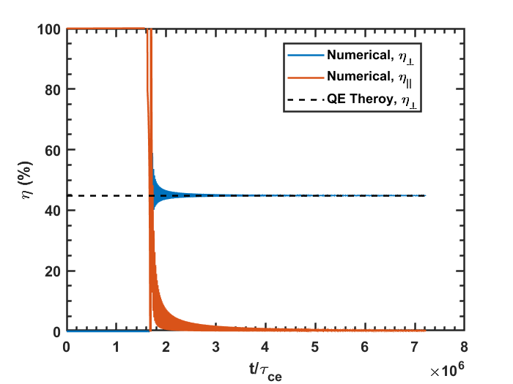
Figure 5. Energy transfer ratio from the static electric field to the gyro kinetic energy $η_{⊥}$ and parallel kinetic energy $η_{∥}$. The parameters used here are the same as in Fig. 2 (QE theory means theory based on quantum equation).

V. Discussion
This trapping effect can be qualitatively understood through the conservation of angular momentum and linear momentum[22]. We can draw an analogy by treating the cyclotron electron as a system that contains both internal and kinetic energy, where the internal energy refers to gyro kinetic energy and kinetic energy refers to its translational motion along the magnetic field. When this system is stimulated by an external E.M wave, it undergoes stimulated emission, radiating E.M waves identical to the external one.
For anomalous doppler resonance, Since the emitted E.M wave propagates in the same direction as the electron, conservation of linear momentum requires the electron to lose some of its parallel momentum to emitted wave. At the same time, because the electron possesses right-hand circular rotation (associated with positive angular momentum), while the emitted wave has left-hand circular polarization (associated with negative angular momentum), conservation of total angular momentum requires the electron to gain angular momentum after emission. As a result, the electron loses kinetic energy and gains gyro kinetic energy. However, a static electric field continues to replenish the lost kinetic energy. When the rate of the electron’s parallel kinetic energy loss to the electromagnetic wave balances the gain from the static electric field, the electron’s parallel velocity stops increasing, and the electron becomes trapped by the electromagnetic wave, while the gyro kinetic energy increases due to angular momentum conservation. This manifests as a continuous transfer of energy from the static electric field to the gyro kinetic energy of the electron.
The redistribution of electron energy between parallel kinetic energy and gyro kinetic energy suggests a possible route for mitigating runaway electrons. Tailored wave injections (e.g., whistler-mode[25]) could induce resonant trapping, helping to suppress runaway electrons. At the same time, the continuous energy transfer from static electric fields to gyro kinetic energy may provide a novel pathway for plasma heating, complementing established methods such as electron cyclotron resonance heating (ECRH). These effects merit further investigation within the framework of wave–plasma interactions.
VI. Summary
In conclusion, trapping under anomalous Doppler resonances is analyzed via the pseudo-potential approach. The parallel velocity oscillates within a potential well, while the perpendicular velocity grows continuously. The critical trapping energy of the electromagnetic wave is obtained numerically and further verified through a first-principles calculation presented in Appendix B. The energy conservation ratios from simulations and quantum theory show strong agreement. The underlying mechanism is explained in terms of angular and linear momentum conservation, and potential applications for runaway electron suppression and plasma heating are discussed.

AUTHOR DECLARATIONS
Conflict of Interest
The authors have no conflicts to disclose.

Author Contributions
Xinhang Xu: Conceptualization (lead); Data curation (lead); Formal analysis (lead); Investigation (lead); Methodology (lead); Visualization (lead); Writing – original draft (lead); Writing – review &editing (lead).
Chengming Qu: Conceptualization (equal); Formal analysis (equal); Investigation (equal); Writing – review & editing (equal).
Xiaoliang Li: Investigation (equal); Writing – review & editing (equal).
Xinliang Gao: Conceptualization (equal); Formal analysis (equal); Investigation (equal); Writing – review & editing (equal).
Jian Liu: Conceptualization (equal); Data curation (equal); Formal analysis (lead); Investigation (lead); Writing – review &editing (lead).
Jinlin Xie: Conceptualization (lead); Data curation (lead); Formal analysis (lead); Investigation (lead); Methodology (lead); Visualization (lead); Writing – original draft (equal); Writing – review &editing (lead).
DATA AVAILABILITY
The data that support the findings of this study are available from the corresponding author upon reasonable request.

Appendix:
A. Prove the relationship between resonant condition and $ξ_{z}$
The parameter $ξ$ characterizes the frequency mismatch relative to the resonance condition given by
$$\begin{aligned}ω=k⋅v+g\frac{Ω}{γ}\#\left( SEQ equation 69\right)\end{aligned}$$
This relationship can be derived as follows: Starting from the definition of $ς$ as shown in Eq.$\left(44\right)$, we have:
$$\begin{aligned}ςβ_{z}^{'}=\frac{ω}{Ω}\frac{n}{γ_{T}}γ^{'}β_{z}^{'}\#\left( SEQ equation 70\right)\end{aligned}$$
Since {$γβ,γ$} are four-vector, we have $\begin{aligned}γ^{'}β_{z}^{'}=γ_{T}\left(γβ_{z}-β_{T}γ\right)=γ_{T}γ\left(β_{z}-\frac{1}{n}\right)\#\left( SEQ equation 71\right)\end{aligned}$Substituting Eq. $\left(71\right)$ and Eq. $\left(70\right)$ into Eq. $\left(13\right)$ gives
$$\begin{aligned}ξ_{z}=1+g\frac{ω}{Ω}\frac{n}{γ_{T}}γ_{T}γ\left(β_{z}-\frac{1}{n}\right)=g\frac{g\frac{Ω}{γ}+k⋅v-ω}{\frac{Ω}{γ}}\#\left( SEQ equation 72\right)\end{aligned}$$
Here$g\frac{Ω}{γ}+k⋅v-ω=0$ represents the resonant condition.
B. Cross-check the threshold through first-principles calculation
To verify the threshold predicted by the pseudo-potential analysis, a direct first-principles calculation is employed. By directly solving the electron’s equation of motion, we can clearly examine the velocity behavior on either side of the threshold.
The electron’s equations of motion for position r and momentum p are given in eq. $\left(73\right)$. Here, E and B represent the total electric and magnetic fields, including both static and electromagnetic components. The variable p denotes the momentum, c is the speed of light in vacuum, r is the electron’s position, e is the electron charge, and $m_{0}$ is the electron rest mass.
$$\begin{aligned}\begin{matrix}\frac{dr}{dt}=\frac{p}{\sqrt{m_{0}^{2}+\frac{p^{2}}{c^{2}}}} \\ \frac{dp}{dt}=-e\left(E\left(r,t\right)+\frac{p}{\sqrt{m_{0}^{2}+\frac{p^{2}}{c^{2}}}}×B\left(r,t\right)\right)\end{matrix}\#\left( SEQ equation 73\right)\end{aligned}$$
The discrete structure of eq. $\left(73\right)$ is rewritten as eq.$\left(74\right)$ by employing the Volume-Preserving Algorithm[20, 21], here the j is the iteration step and the operator Cay(A) denotes the Cayley transform of matrix A.
$$\begin{aligned}\left\{\begin{matrix}r_{j+\frac{1}{2}}^{*}=r_{j}^{*}+\frac{Δt^{*}}{2}\frac{p_{j}^{*}}{γ_{j}}, \\ p^{*-}=p_{j}^{*}+\frac{Δt^{*}}{2}E_{j+\frac{1}{2}}^{*}, \\ p^{*+}=Cay\left(\frac{Δt^{*}\hat{B^{*}}}{2γ^{*-}}\right)p^{*-} \\ p_{k+1}^{*}=p^{*+}+\frac{Δt^{*}}{2}E_{j+\frac{1}{2}}^{*}, \\ r_{j+1}^{*}=r_{j+\frac{1}{2}}^{*}+\frac{Δt^{*}}{2}\frac{p_{j+1}^{*}}{γ_{j+1}},\end{matrix}\right.\#\left( SEQ equation 74\right)\end{aligned}$$
The dimensionless parameters are momentum $p^{*}=p/(m_{e}c)$, magnetic field $B^{*}=B/(\frac{m_{e}}{eτ_{ce} })$, total electric field $E^{*}=E/(\frac{m_{e} c}{τ_{ce} e})$, time step $Δt^{*}=Δt/τ_{ce}$ , and position $x^{*}=x/(τ_{ce} c)$ respectively, where the $τ_{ce}$ is the electron cyclotron period and $γ^{*}=\sqrt{1+p^{*2} }$ is Lorentz factor.
Consider the same scenario as given in Fig.1, with E₀ = −0.2 V/m $\vec{e_{z}}$ and B₀ = 2 T $\vec{e_{z}}$. The electromagnetic wave is given by Eq. (1) and Eq. (2), with g = 1, $ω=1.1 Ω$ and k = 1290 m⁻¹. The wave electric field intensity E_{w} is chosen as 104*|E0| and 108*|E0|, respectively.
The evolution of $β_{z}$ and $β_{⊥}$ is shown in Fig. 6. When the wave intensity is E_{w}/|E₀|=104, the parallel velocity is not trapped by the electromagnetic wave, as indicated by the blue curve in Fig. 6(a). When the wave intensity reaches E_{w}/|E₀|=106, the parallel velocity becomes trapped by the electromagnetic wave under anomalous Doppler resonance, and the perpendicular velocity increases continuously after trapping, as shown by the red curve in Fig. 6 (b). This difference demonstrates that the threshold $E_{⊥c}/E_{0}$ lies between 104 and 108, which agree well with the value $\frac{E_{⊥c}}{|E_{0}|}=106$ predicted by the pseudo-potential analysis.
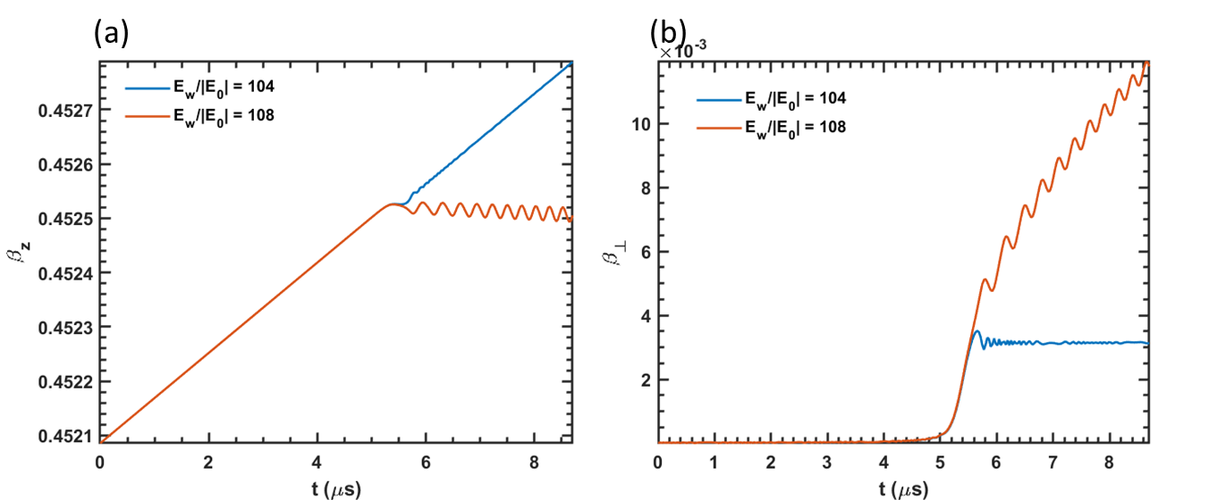
Figure 6. Time evolution of the electron velocity under different electromagnetic wave intensities: (a) parallel velocity; (b) perpendicular velocity.

References
[1] Golovanivsky K S 1982 The Gyrac - a Proposed Gyro-Resonant Accelerator of Electrons Ieee T Plasma Sci 10 120-9
[2] Gal O 1989 GYRAC: a compact, cyclic electron accelerator Ieee T Plasma Sci 17 622-9
[3] Shprits Y Y, Runov A and Ni B 2013 Gyro‐resonant scattering of radiation belt electrons during the solar minimum by fast magnetosonic waves Journal of Geophysical Research: Space Physics 118 648-52
[4] Gary S P, Montgomery D and Swift D W 1968 Particle Acceleration by Electrostatic Waves with Spatially Varying Phase Velocities Journal of Geophysical Research 73 7524-+
[5] Sheena Z, Ruschin S, Gover A and Kleinman H 1990 High-Efficiency Nonadiabatic Trapping of Electrons in the Ponderomotive Potential Wells of Laser Beats Ieee J Quantum Elect 26 203-6
[6] Mozer F, Agapitov O, Giles B and Vasko I 2018 Direct observation of electron distributions inside millisecond duration electron holes Physical Review Letters 121 135102
[7] Grach V S, Artemyev A V, Demekhov A G, Zhang X J, Bortnik J, Angelopoulos V, Nakamura R, Tsai E, Wilkins C and Roberts O W 2022 Relativistic electron precipitation by EMIC waves: Importance of nonlinear resonant effects Geophysical Research Letters 49 e2022GL099994
[8] Millan R and Baker D 2012 Acceleration of particles to high energies in Earth’s radiation belts Space Science Reviews 173 103-31
[9] Bellan P M 2013 Pitch angle scattering of an energetic magnetized particle by a circularly polarized electromagnetic wave Physics of Plasmas 20
[10] Bourdier A and Gond S 2000 Dynamics of a charged particle in a circularly polarized traveling electromagnetic wave Physical Review E 62 4189-206
[11] Liu H, He X, Chen S and Zhang W 2004 Particle acceleration through the resonance of high magnetic field and high frequency electromagnetic wave arXiv preprint physics/0411183
[12] Nusinovich G S, Korol M and Jerby E 1999 Theory of the anomalous Doppler cyclotron-resonance-maser amplifier with tapered parameters Physical Review E 59 2311
[13] Nusinovich G S, Latham P and Dumbrajs O 1995 Theory of relativistic cyclotron masers Physical Review E 52 998
[14] Qian B L 1999 An exact solution of the relativistic equation of motion of a charged particle driven by a circularly polarized electromagnetic wave and a constant magnetic field Ieee T Plasma Sci 27 1578-81
[15] Qian B L 2000 Relativistic motion of a charged particle in a superposition of circularly polarized plane electromagnetic waves and a uniform magnetic field Physics of Plasmas 7 537-43
[16] Roberts C S and Buchsbaum S 1964 Motion of a charged particle in a constant magnetic field and a transverse electromagnetic wave propagating along the field Physical Review 135 A381
[17] Weyssow B 1990 Motion of a single charged particle in electromagnetic fields with cyclotron resonances Journal of plasma physics 43 119-39
[18] Liu C, Hirvijoki E, Fu G-Y, Brennan D P, Bhattacharjee A and Paz-Soldan C 2018 Role of kinetic instability in runaway-electron avalanches and elevated critical electric fields Physical Review Letters 120 265001
[19] Xie Z-K, Zong Q-G, Yue C, Zhou X-Z, Liu Z-Y, He J-S, Hao Y-X, Ng C-S, Zhang H and Yao S-T 2024 Electron scale coherent structure as micro accelerator in the Earth’s magnetosheath Nature Communications 15 886
[20] Zhang R L, Liu J, Qin H, Wang Y L, He Y and Sun Y J 2015 Volume-preserving algorithm for secular relativistic dynamics of charged particles Physics of Plasmas 22
[21] Liu J, Wang Y L and Qin H 2016 Collisionless pitch-angle scattering of runaway electrons Nuclear Fusion 56
[22] Xu X, Xie J, Liu J and Liu W 2025 Analysis of the Anomalous Doppler Effect from Quantum Theory to Classical Dynamics Simulations Chinese Physics B
[23] Pokol G, Kómár A, Budai A, Stahl A and Fülöp T 2014 Quasi-linear analysis of the extraordinary electron wave destabilized by runaway electrons Physics of Plasmas 21
[24] Nezlin M V 1976 Negative-energy waves and the anomalous Doppler effect Soviet Physics Uspekhi 19 946
[25] Guo Z H, McDevitt C J and Tang X Z 2018 Control of runaway electron energy using externally injected whistler waves Physics of Plasmas 25

